

Lab 01

Introduction to DevOps



April 7, 2025

Submitted to: sIR tALHA gHOURI

Submitted By: Muhammad Soban Mallick and Muhammad Umer

**TASK 1:**

**3.**

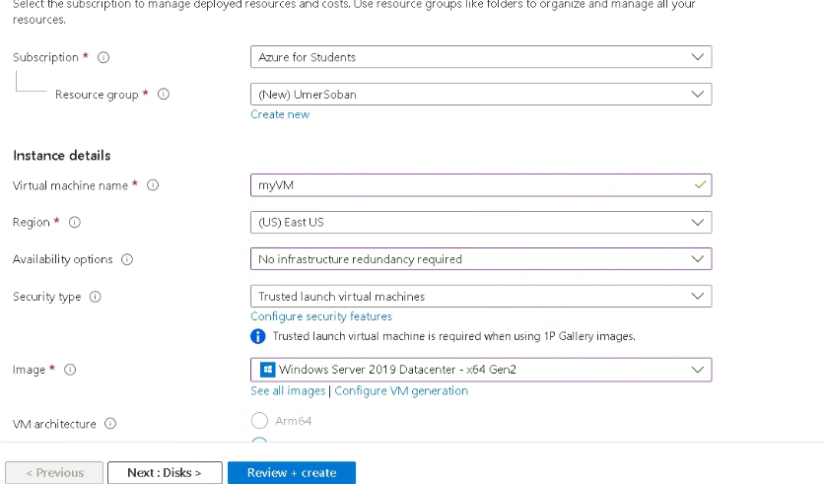

**4.**

**5.**

**8.**

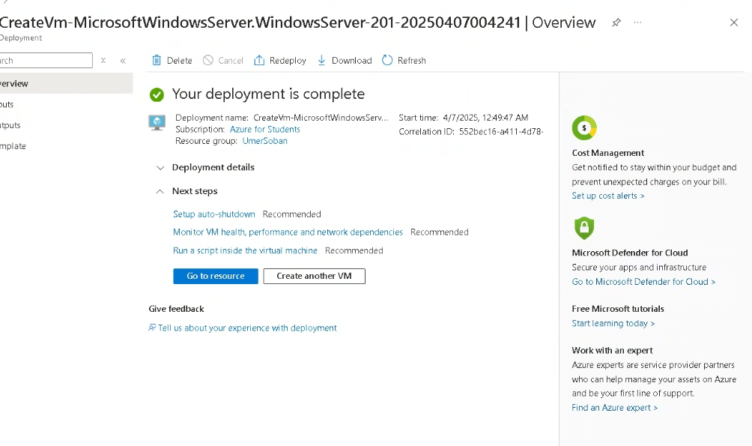

**TASK 02:**

**1.**

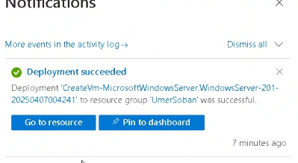

**2.**

**3.**

**4.**

**5.**

**6.**

**TASK 03:**

**1.**

**2.**

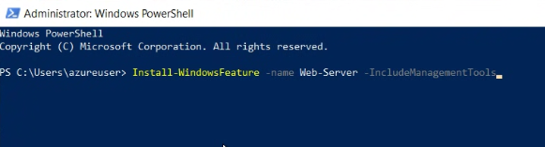

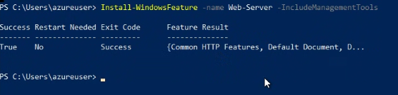

**3.**

